**Alaska tribe establishes Sitka lab to test shellfish for biotoxins**

By [**Cathy Siegner**](https://www.foodsafetynews.com/author/csiegner/) on May 10, 2016

The Sitka Tribe of Alaska has set up an environmental research and testing lab in Sitka and plans to begin testing local shellfish for biotoxins this spring. There has reportedly been some concern about the distance and turnaround time to have locally harvested shellfish tested in Anchorage by the state, which currently operates the only FDA-certified lab in Alaska.

[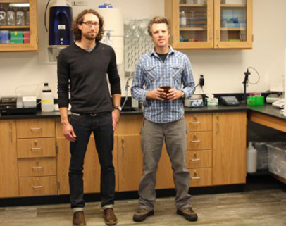](https://www.foodsafetynews.com/files/2016/05/Sitka-lab-guys-1.jpg)Michael Jamros, lab manager (left), with Chris Whitehead, founder of the Southeast Alaska Tribal Ocean Research group in Sitka. *(Photo by Emily Kwong/KCAW)*Eating shellfish such as clams, oysters, cockles and mussels can put humans at risk of paralytic shellfish poisoning. According to the [Washington State Department of Health](http://www.doh.wa.gov/CommunityandEnvironment/Shellfish/BiotoxinsIllnessPrevention/Biotoxins) (DOH), the problem comes when the shellfish eat toxin-producing algae and people eat the shellfish. DOH’s website notes that while the biotoxins don’t harm the shellfish, they can accumulate to levels that can cause illness or death in humans and other mammals who consume them. An April 26 report by KCAW radio in Sitka said the tribe plans to open the lab sometime this month if the test samples being sent to the National Oceanic and Atmospheric Administration (NOAA) in Seattle check out. The lab has a plate reader, a machine that can analyze for shellfish toxins. Five ounces of shellfish tissue are needed for each test, and lab manager Michael Jamros runs Enzyme Linked Immunosorbant Assays measuring the toxicity of shellfish samples. The data are then analyzed and the toxin level determined. The tribe’s environmental program manager, Chris Whitehead, came up with the plan for the new lab. He said he realized soon after arriving in Sitka in 2013 that the state didn’t have the kind of warning system DOH provides for those who harvest shellfish in Washington state. “Native people have been harvesting clams for thousands of years. A lot of the elders I talk to don’t do it anymore because they just don’t know. So, to be able to bring that back and be able to utilize that resource is huge,” he said. [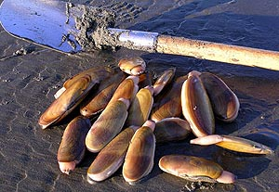](https://www.foodsafetynews.com/files/2016/05/razor_clams-thumb-1.jpg)Harvesting razor clams.Whitehead also realized that sending locally harvested shellfish samples off to Anchorage for testing and waiting for results wasn’t an ideal situation from a public health standpoint. So he gathered together a coalition of tribes and formed the [Southeast Alaska Tribal Toxins network](http://www.seator.org/seatt) to monitor local beaches for toxic algae blooms and then secured $1 million in grants for the next three years. “So those sites will be monitored at the expense of the tribe and the resources that the tribes have every other week. So every tide cycle pretty much,” Whitehead told KCAW. The monitors will be checking plankton, identifying harmful species, and recording and sharing the information. The Alaska Department of Environmental Conservation must prioritize [testing shellfish](http://dec.alaska.gov/EH/fss/seafood/Shellfish_Home.html) samples it receives from commercial harvesters over those from subsistence ones, said Patryce McKinney, chief of the department’s environmental health lab in Anchorage. She said the lab’s regulatory fee for doing paralytic shellfish toxin testing for recreational harvesters is $125 per sample, while commercial shellfish sample testing is covered by cruise ship excise fees. According to a [recent economic analysis](http://www.iser.uaa.alaska.edu/Publications/2015_12-FiscalEffectsOfCommercialFishingMiningTourism.pdf) from the University of Alaska-Anchorage, the cost for doing shellfish and other testing for the commercial fishing industry in fiscal year 2014 totaled $649,900. [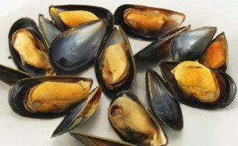](https://www.foodsafetynews.com/files/2016/05/musselsDSP-406.jpg)Mussels“They (the commercial shellfish industry) don’t have a choice where they go (for testing). Most products are tested before they go into commerce, and some are even tested before harvest,” McKinney explained, noting that the lab typically sends out same-day preliminary results. She said the state-subsidized three-year [pilot program](http://dec.alaska.gov/EH/fss/seafood/Docs/2013_Alaska_BivalveShellfish-Marine_%20Biotoxin_Monitoring_Plan.pdf) for biotoxin monitoring of subsistence-harvested shellfish ended last year and resulted in a few remote Alaskan communities opting to continue the plan on their own. Of the pilot program shellfish samples her lab tested, “They failed more often than not,” McKinney noted. “I don’t think it’s because of the kind of harvest but more the location of the harvests. There are known areas that get high results, and all of these are beaches,” she said. Going forward, the tribe’s plan is for those who harvest shellfish for personal use in southeast Alaska to send samples to the Sitka lab and get test results back within one business day. If any test results reveal unsafe toxin levels, the tribe will send out a community-wide alert, according to the lab’s [website](http://www.seator.org/Lab). The Sitka lab also plans to do testing for commercial shellfish harvesters at some point in the future, which would require FDA certification. More information on the lab’s testing protocols can be found [here](http://www.seator.org/Lab). ***(To sign up for a free subscription to Food Safety News, click***[***here***](https://www.foodsafetynews.com/subscribe/#.VcL0VsZNPVs)***.)***

Tags: [Alaska](https://www.foodsafetynews.com/tag/alaska/), [algae blooms](https://www.foodsafetynews.com/tag/algae-blooms/), [biotoxins](https://www.foodsafetynews.com/tag/biotoxins/), [clams](https://www.foodsafetynews.com/tag/clams/), [mussels](https://www.foodsafetynews.com/tag/mussels/), [NOAA](https://www.foodsafetynews.com/tag/noaa/), [oysters](https://www.foodsafetynews.com/tag/oysters/), [paralytic shellfish poisoning](https://www.foodsafetynews.com/tag/paralytic-shellfish-poisoning/), [shellfish](https://www.foodsafetynews.com/tag/shellfish/), [Sitka Tribe of Alaska](https://www.foodsafetynews.com/tag/sitka-tribe-of-alaska/), [Southeast Alaska Tribal Toxins network](https://www.foodsafetynews.com/tag/southeast-alaska-tribal-toxins-network/)