**[Barn swallows and thixotropy](https://onthetrailsjuneau.wordpress.com/2017/03/08/barn-swallows-and-thixotropy/) by Mary Willson**

dabbing and daubing for stable nests

One day in early September, I was fascinated by a pair of barn swallows still feeding big chicks in the pavilion by the visitor center. All the other pairs there had long since fledged their chicks, and those chicks would be experienced foragers by the time of migrations to southern climes. The September chicks would leave the nest soon, but they would have a lot to learn about catching insects on the wing, and it seemed unlikely that they’d be proficient foragers by migration time. An uncertain fate!

As I looked at that nest, I began to wonder about how barn swallows manage to build such a nest. Their nests are shallow cups made of little mud balls stuck together, and lined with feathers. Their relatives, the cliff swallows, build a more elaborate, gourd-shaped nest with a narrow entrance, but they use the same basic technique—mud pellets stuck together and the whole edifice stuck to the side of a building or cliff.

But what makes the pellets stick to each other? In a nest under construction, the first pellets to be placed have had a chance to dry a little, and when they dry, they shrink a bit. If a swallow just plopped new, wet pellets into place, the shrinkage rates of the new and old pellets would differ, and this creates weakness and cracks in the structure (a result well known to human potters). Not a good result.

That’s where thixotropy comes in. It’s a fancy but concise way of describing what happens to some seemingly stable materials when they are mechanically agitated. They become fluid, temporarily, and a little later become stable again, often in a new configuration. It turns out that thixotropy (from the Greek words for ‘touch’ and ‘change’) is characteristic of many materials and situations. It’s involved with some metal casting, certain printing processes, and some foods, for example. Perhaps most famously, it can happen during earthquakes, which shake and liquefy wet soils, causing buildings and trees and everything else to sink or tip or slide, sometimes catastrophically.

Animals use this curious phenomenon too. When bald eagles dance up and down on wet sand in order to capture buried sand lance, one effect of their prancing is liquefying the sand, making the fish more accessible. Gulls can use the same trick.

Mud dauber wasps build little cells of mud, stuck to walls. When they add new pellets to the cells, they add a bit of water from their crop, and they buzz. The vibrations liquefy the mud, letting it spread into the earlier, drier pellets. Then old and new pellets vibrate together, achieve the same consistency, and are stable when vibration stops.

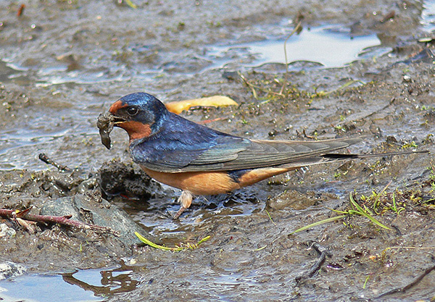Gathering mud. Photo by Bob Armstrong

That brings us back to barn swallows. They collect mud pellets from puddles and gradually add several rows of pellets to form the nest cup. But they apparently don’t just whack each new pellet into place. Instead, when they add pellets to the growing base, they use a dabbing or dabbling motion. This jiggles the old (drier) and new (wetter) pellets until the water content is similar and their consistency is equalized. As soon as the dabbling stops, the junction of new and old pellets becomes stable. Wouldn’t it be fun to find out if young adult barn swallows know to do this automatically or if they have to learn the hard way (if their first nest-building attempts collapse)!