**[Barn swallows](https://onthetrailsjuneau.wordpress.com/2017/03/08/barn-swallows/) by Mary Willson**

a complicated society

I like to go up around the Mendenhall Glacier Visitor Center for lots of natural history reasons, and one of them is to watch the barn swallows that nest in the pavilion, the bus shelter, on the sides of the center itself, and sometimes on the kiosk. The insect-catching adults swoop high and low, sometimes playing ‘chicken’ with the numerous cars and buses, which typically exceed the posted speed limits. Most of the thousands of tourists are oblivious to these birds, but a few do pay attention.

In mid July, some of the nests had big chicks, either just leaving the nest or just about to do so. Other pairs still had eggs, in some cases because vandals had destroyed their first nests and these pairs had to begin anew.

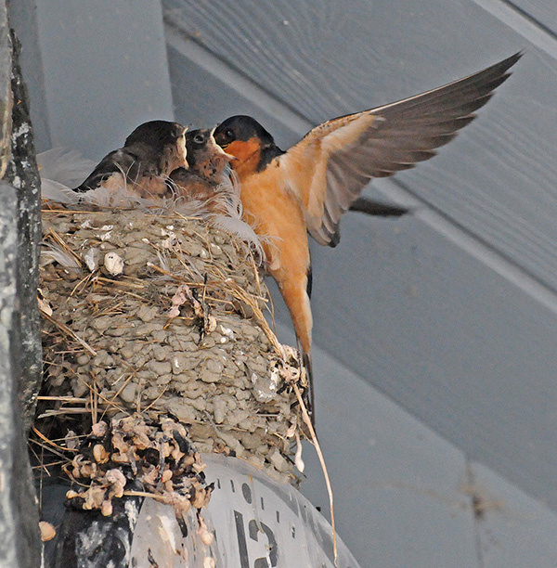Photo by Bob Armstrong

Originally, barn swallows nested in caves, cliff crevices, and hollow trees, but now they have converted to using human structures almost entirely. They build inside culverts, under bridges, and on buildings; use of natural sites has become unusual and noteworthy. Historically, as North American became more populated by humans, barn swallows also spread into new areas.

Barn swallows occur all over the northern hemisphere in the nesting season (but migrate to South America or Africa in winter), and they are among the most intensively studied songbirds. European birds have white breast and belly feathers, but in North America these feathers are rusty orange. It turns out that in North America, a dark rusty breast on a male is attractive to females, and females mated to dark rusty males produce more chicks than those mated to paler males.

In this species, the elegant tail is long and forked, and males have longer tails than females. A deeply forked tail is said to increase lift and allow tighter turns, and if the fork is symmetrical, maneuverability is enhanced. Long, symmetrical tails develop on males that have few external parasites. Females really go for males with long, symmetrical tails—the best fliers with the fewest parasites. So males with such tails have a high probability of getting a mate, they get better mates, and they indulge in more extracurricular copulations as well. Females that are socially bonded to short-tailed males actively seek extra-pair copulations with better-endowed males.

However, those studly males with big tails don’t invest much time and energy in the chicks of their ‘official’ mate: they’re too busy running around. The short-tailed males are more attentive fathers; they also reportedly build better nests, and females are also more attentive moms when they have better nests. So there is some compensation to females for not being mated to the studliest guy. But the nests of short-tailed males often contain some other male’s chicks, so the short-tailed males end up investing effort in chicks that are not their own.

If all that were not enough complexity, barn swallow nests are sometimes subject to hostile takeovers by intruding males. The marauding male may belong to another species, such as a wren, or house sparrow, or cliff swallow. And sometimes the intruder is another barn swallow. If the intruder pushes out the original male, he generally destroys any eggs or small chicks, and then mates with the widowed female.

Nests are built of pellets of mud, cemented to the wall or beam, and lined with grass and especially feathers. Both parents incubate the eggs, although only the female has a featherless, highly vascularized brood patch on her belly. Incubation takes about two weeks and chicks are in the nest roughly three weeks. After leaving the nest, the juveniles are tended by their putative parents for about two more weeks. Chicks in a second brood are sometimes also tended by older siblings from the first brood. Parents (and older sibs) can recognize their fledglings, not by voice, but by variation in plumage color patterns on the chest—no two chicks are exactly alike.

Barn swallows nest in several locations in Juneau and are easily seen. Next time you see one, just think a moment about how complex their lives are.