Bumblebees by Mary Willson
be kind to them!
In early spring, I look forward to seeing the first bumblebees, visiting willow catkins and early blueberry flowers. These ae queens, which mated last fall and then hibernated, each one usually in a small chamber she dug in the soil. Bumblebees can regulate their own body temperature by shivering (as can dragonflies and hawkmoths), and so they are able to be active when many other insects are immobilized by cool temperatures.
The springtime queens find sites for their nests, often using abandoned mouse or vole nests. They need the insulation provided by the fur, dry grass, moss, and feathers that the rodents gathered, but they may also drag in additional material from nearby. In each nest, a queen builds a wad of pollen on which the eggs are laid and the larvae will feed; she also builds a tiny nectar pot where she stores nectar for herself. The queen incubates her brood and feeds the larvae on regurgitated pollen and nectar. Total development time from egg to adult bee takes four to five weeks. The first brood of the season is typically small, fewer than twenty eggs; later ones may be larger, because there are then worker bees to help raise them.
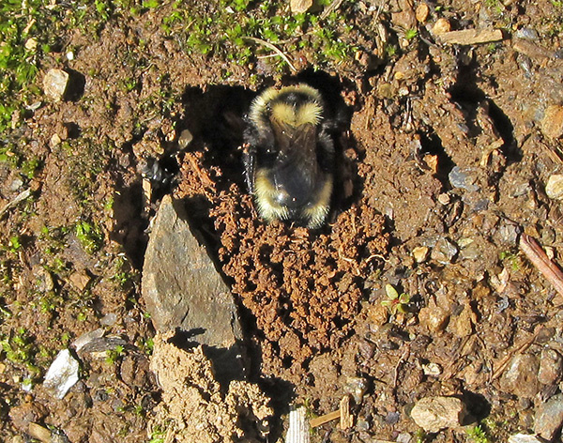Digging a nest. Photo by David Bergeson
Newly emerged adults are mostly workers; some stay in the nest to help tend the next brood and other become foragers, gathering nectar and pollen to feed the growing colony. Different kinds of flowers provide different quality (and quantity) of nectar and pollen: some nectars are rich in sugars and may differ in the specific sugars provided. Pollens also differ among flower species, with some (for example, legumes such as lupine and beach pea) having higher protein and different amino acid composition than others (such as roses and blueberries).
Foraging bumblebees can be quite selective in their choice of flowers, and the more well-stocked the nest larder, the more selective they become. They learn to use visual cues such as color and shape, and respond to the level of food reward (nectar or pollen) offered by the flower: flowers that offer high rewards are visited more often. And they learn how to handle different kinds of flowers, some of which hid the nectar or pollen deep inside a complex structure (think of lupine or monkshood) that requires a bee to manipulate the flower in a certain way to gives access to the food reward and achieves deposition of pollen and transport of pollen to another flower.
Foragers also learn to use scent cues, provided by the flower and by other bees. Foraging bees can leave scent marks on flowers they’ve visited, cuing other workers to avoid the depleted flower. When successful foragers return to their nest, they can signal their success to other workers. The returning forager runs around the nest excitedly and releases particular scents that stimulate other workers to search for the floral scent carried by returning bee. Unlike the more famous honeybees, however, bumblebees don’t signal the direction in which the food source was found.
Later in the summer, queens (and in some cases, workers too) begin to lay unfertilized eggs, which develop into males. The males do little around the house, so to speak, but sally forth to feed and look for mates. Males of many species establish a scent-marked route through their habitat, leaving their scent marks on selected sites such as rocks or tree trunks; they then patrol the route in hopes of attracting females. Other species set up small territories and perch there, defending their chosen spot from other males and waiting to accost a passing female. The females of interest are newly emerged queens; when mating is successful, the new queens go on to find hibernation sites in which to await the coming of spring. The workers die off and our new queen bumblebees may have gone to bed by now.
Many hazards threaten bumblebee colonies. Domestic colonies of bumblebees spread disease to wild populations. There are predators and parasites, of course, and environmental hazards such as flood, habitat destruction by humans, pesticides, and so on. In addition, occasionally the balance of power between a queen and her workers shifts, and the workers kill their mother; they may then rear their own sons (from unfertilized eggs). Sometimes a late-emerging queen who fails to find a good nest site turns assassin, invading a recently established nest of the same (or closely related) species, killing the resident queen if possible, after an intense battle, and usurping the brood of workers to rear her own offspring.
There is a distinctive type of bumblebee called the cuckoo bees. They are tougher and have more powerful stings than regular bumblebees. They make their living by invading young colonies, killing the queen, and usurping the old queen’s position in charge of the colony. The invader may kill and eat the host’s eggs and larvae; any surviving workers rear the invader’s offspring, all of which will be males or future queens of the invader’s species (the host nest seldom produces queens after it has been invaded by cuckoos).
Here in Southeast, a recent publication indicates that we may have about seven species of bumblebee (of over forty in North America), including one species of cuckoo bee. They are essentially impossible for non-experts to identify without killing the specimen. The easily visible banding patterns of yellow and black and sometimes red are remarkably variable over the range of a species and can vary even within more limited areas.
Difficult to identify but fun to watch: what flowers are being visited, how does the bee handle the flower, how long does each visit last, does a given bee visit more than one kind of flower and if so, where on the bee is the pollen deposited. The questions are many.
A cautionary note: Be nice to our bumblebees! Many populations of bumblebees are declining, rapidly in some areas. But we need them to pollinate our flowers! Without good pollination, there would be poor fruit crops, hungry bears and birds, much less jam and pie– a very sorry state of affairs!

