Canada geese by Mary Willson
migrants and residents among us
Most folks love to hear flocks of Canada geese flying overhead, especially in spring when the northward migrations pass over Juneau. Sometimes the flocks land in local wetlands to feed, fueling the next leg of the journey.
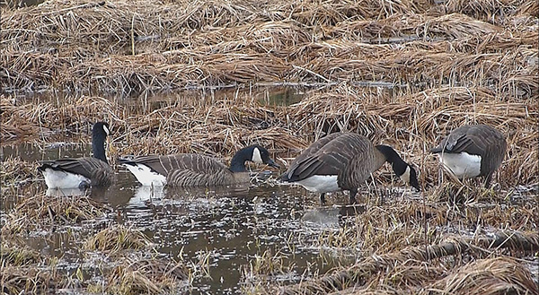Photo by Bob Armstrong
On a mid-February hike near the scout camp, a small group of geese foraged in the meadow, and we managed to circle around them without sending them into an alarmed flight. Another small group flew in to join them, talking constantly with each other.
Several of the hikers remarked that it seemed rather early for the migrating flocks of geese to be here. Indeed it was! The geese we saw belong to a distinct sub-species, known as Vancouver Canada geese, that occupies Southeast Alaska and British Columbia year-round (although a few may migrate). In winter, we often see these residents on wetlands and in estuaries along Juneau shores. For instance, Echo Cove, the Cowee Creek estuary, Eagle Beach, the Mendenhall wetlands, and the Lemon Creek wetlands are often good places to see them.
Vancouver Canada geese are unusual in several ways (in addition to being here all year). They are larger than other subspecies of Canada geese; adults weigh an average of six to ten pounds in fall but even more in spring. And they nest in wooded areas, not in open areas such as marshes and tundra—habitats that are more typical of other subspecies; in short, Vancouvers have adapted to the commonly available habitats here in Southeast.
Nests are usually placed at the base of a pine or a group of pines in muskegs or at the base of a spruce or hemlock in denser forest. But sometimes, the nest is on a snag or even in a live tree. Nest sites can be far from tidal waters and are not usually adjacent to freshwater ponds; the nearest open water is likely to be a small, shallow forest pool. Whereas other Canadas escape to open water when disturbed, Vancouvers flee to cover in the forest. During the incubation period, the male may stand guard while perched high in a nearby tree; those great webbed feet somehow manage to let a big goose perch on a branch!
Other than residency, habitat, and body size, Vancouvers are much like the rest of the species. Males and females have similar plumage, but males are slightly larger. They reach breeding age in two or three years after hatching. They form long-lasting pair bonds; but if one member of a pair dies, the widow(er) may find a new mate. Each pair sets up a nesting territory, excluding other pairs.
Females do the job of incubating the eggs, for about four weeks, while the male keeps watch. There are usually four to six eggs in each clutch, but the average clutch size is smaller in nests that are started later in the season. Not much is known about nesting success, in part because the birds are so secretive and nests are hard to find. Even with radio-tracking, finding nests takes considerable effort. So it seems that only two studies of nesting success have been done, both on Admiralty Island, and the sample sizes are small (fewer than twenty-five nests in each study). A study in the 1970s found that eggs successfully hatched in fifty-six percent of monitored nests, and a later study found that about eighty percent of nests survived to hatching time. These estimates lie within the range reported for other populations. Canada geese whose nest is destroyed can sometimes renest in the same season, but the clutch size is smaller and obviously hatching time would be delayed. So juveniles would not be as well-developed when fall comes, but the consequences of such a delay have apparently not been studied.
After the eggs hatch, the goslings are able to walk, swim, and forage within a day’s time. They are guarded by their parents, which call out alarms if disturbed and shoo the young ones into cover. Sometimes, several broods of goslings are gathered together in what is called a crèche, and all the parents attend them. Goslings are able to fly after about eight or ten weeks, but they stay with their parents for a year.
After the nesting season, the geese molt and become flightless for several weeks while new flight feathers grow in. At least in some cases, birds seem to have favorite molting sites, probably not terribly far from where they nested, where they gather in flocks. I’ve paddled into Wachusett Inlet in Glacier Bay, for instance, and found the water surface littered with goose feathers (I soon retreated, so as not to disturb any still-flightless birds).
Canada geese are herbivores, eating a great variety of vegetation. Grasses and sedges are a mainstay in summer. In Southeast, a favored summer food is skunk cabbage leaves, but they also eat blueberry leaves and fruits and other things. On local wetlands, we have found evidence that they dig up the underground parts of silverweed, and in winter, we see them grubbing up the underground parts of sedges. We have sometimes found scats filled with poorly digested moss, which seemed unusual. The digestive system of these geese is not highly efficient, despite a good gizzard and a substantial microbial flora in the caecum and intestines, so they have to eat a lot.
Based on aerial surveys, the population of Vancouvers in Southeast is estimated to be about twenty thousand or a little more. It appears to be fairly stable, perhaps partly because it is not subject to excessive hunting pressure; historically, other populations in Alaska have crashed because they have been overharvested (in the Yukon-Kuskokwim area) or devastated by introduced foxes (on the Aleutians).
Thanks to Debbie Groves, US Fish and Wildlife Service, who provided several useful references.

