Canada geese by Mary Willson
many subspecies, habitats, and sizes
A favorite sign of spring is a flight of Canada geese, winging northward in the familiar V- formation, talking to each other as they go. I hear them coming, tip my head back, and wait—and then there they come. Gradually the melodic calls fade away in the distance. There’s nothing quite like it!
A migrating flock of Canadas is a very familiar sight for many people. So perhaps it is not very surprising to hear someone say, as we are driving down Egan over Lemon Creek, “Oh look, the geese are back!!” But the geese seen there and elsewhere on the wetlands in winter and early spring are not migrants. They can be found somewhere on the wetlands at any time during the winter; an estimated five or six hundred Canadas spend the winter with us.
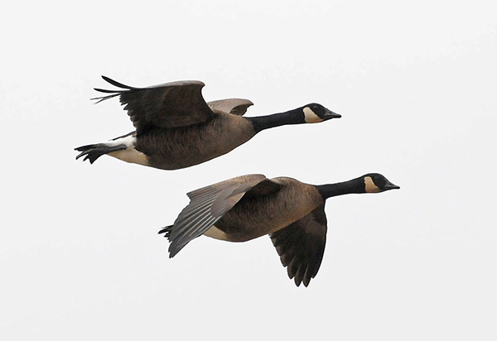Vancouver Canada Geese in flight. Photo by Bob Armstrong
These geese belong to a coastal subspecies, whose geographic range roughly coincides with the coastal rainforest. They are considered to be non-migratory, although these birds may make short-distance movements at certain seasons.
Of course, we have some migratory Canadas too, in season. One subspecies nests chiefly on the Copper River Delta, and passes through here, to and from its wintering grounds a little farther south. Another subspecies nests in the Interior, and part of that population winters in California, coming by us in spring and fall. In addition, there is the small Cackling Goose, which looks like a miniature Canada Goose but is now considered to be a different species; it can occasionally be seen here as it flies between western Alaska and California.
The entire species we know as Canada goose is widespread in North America. It is divided into several (or many, according to some researchers) subspecies. The birds of some subspecies are very large; for example the one that uses the Mississippi flyway averages maybe 4500g (almost ten pounds). The Cackling Goose is quite small, averaging roughly 1600g. Our resident birds, known as the Vancouver Canada goose, are intermediate in size, averaging over 3000g.
The Vancouver Canada geese nest in rather dense rainforest, unlike most other subspecies, which typically use open habitats near water. Vancouver Canadas usually place their nests on the ground (as do other subspecies), but sometimes the nests are on snags or in trees, as much as 15 m above the ground. Some nests are in muskegs, and many nests are relatively close to muskegs and small pools of standing water. Nests are not necessarily close to ponds or lakes.
Male and female form a long-term pair bond, spending their lives together. During the month-long incubation period, when the female is incubating, the male commonly perches high in nearby trees, standing guard. Clutch sizes vary greatly, but often there are three to five eggs; older females usually lay larger clutches and larger eggs than young females.
Broods of Vancouver Canada geese use dense understory as escape habitat when threatened by potential predators. This is quite different from other subspecies, whose nests are commonly close to water and whose broods typically flee to open water. As the rainforest goslings grow, they are found more often in open habitats, not necessarily near the nest site. They often band together with other broods in crèches, which are thought to reduce the risk of aerial predation. Young birds stay with their parents though the winter.
Nest success can vary enormously, depending on weather and predator activity. For the rainforest subspecies, and for the species as a whole, as few as 25% of nests may be successful in producing goslings, but in good conditions, sometimes over 80% of nests are successful. Cold, wet weather is deleterious to nest success, and areas with many predators (for example, foxes, coyotes, ravens, mink, bears) may lose most of the nests. The age of the female also matters: older females are generally more successful than younger ones.
Although the geese may mature at an age of two years, some do not mature until they are three years old. If they are lucky, they may reproduce for several years.
After the nesting season, in late summer, Canada Geese molt their worn flight feathers, so for three or four weeks they cannot fly. In preparation for molting, Vancouvers typically move relatively short distances to selected, protected bays and inlets, where foraging is good. There they grow their new flight feathers in relative peace. Wachusett Inlet in Glacier Bay is one of molting sites; if you kayak into this inlet just after molting time, the water surface is covered with goose feathers.
Canada Geese are herbivores, grazing on many kinds of plants in the course of a year. The Vancouver Canada Goose likes skunk cabbage leaves in the nesting season; one can often see the bite marks on the standing leaves. They also eat blueberries, lingonberries, and crowberries in season. In late winter and early spring, the Vancouvers often forage on the roots and young shoots of sedges in the wetland. Most goose foods are not highly digestible or high quality, and the digestive processes of geese are reported to be moderately inefficient, so geese need to eat a lot. There are reports that they may sometimes snack on small clams and worms, drifting salmon eggs, and even dead salmon.
The need to eat large quantities of vegetation means that geese spend a lot of time just eating. A group of foraging geese usually has one or two individuals standing upright, as sentinels, to warn of approaching danger. If wandering people or dogs come too close, the flock will take off and seek a less disturbed foraging area. Flight is expensive, and the more the birds are disturbed, the more food they need to pay the costs of flight. So frequent disturbance makes it hard for them to get enough food.
During the hunting season on the Mendenhall Wetlands, geese become very wary and easily disturbed. In fact, observers have noticed that geese (and ducks) often leave the wetlands during the day and fly to Auke Lake, in order to avoid the hunters. They come back to the wetlands at night to forage. Unfortunately, these daily flights cross the paths of approaching airplanes—not good for either goose or plane!

