Chickadees by Mary Willson
a common bird with an uncommon memory
A friend and I stood in a small muskeg on Douglas, checking out some deer tracks, when little twitterings announced the arrival of chickadees. Two of them scoured the twisted trunk of a dead pine right next to us, but we soon saw that there were two more—no, four more—no, maybe six or eight more—thronging the foliage of nearby hemlocks. They might be finding overwintering spiders or insect pupae and even adults.
I enjoy watching the flock that hang out around my house, too, as they diligently pick out little black sunflowers seeds from the feeders and flit into the adjacent spruces. They may eat some of those seeds immediately but sometimes the return trip to the feeder happens so quickly that there was only time to stash the seed in a hand crevice for a later snack.
Watching these chickadees stirred me to dig for more information. The species that lives in our area is the chestnut-backed chickadee, which lives principally in the Pacific coastal rainforest. Of the seven species of chickadee in North American, four (including ours) breed regularly in Alaska.
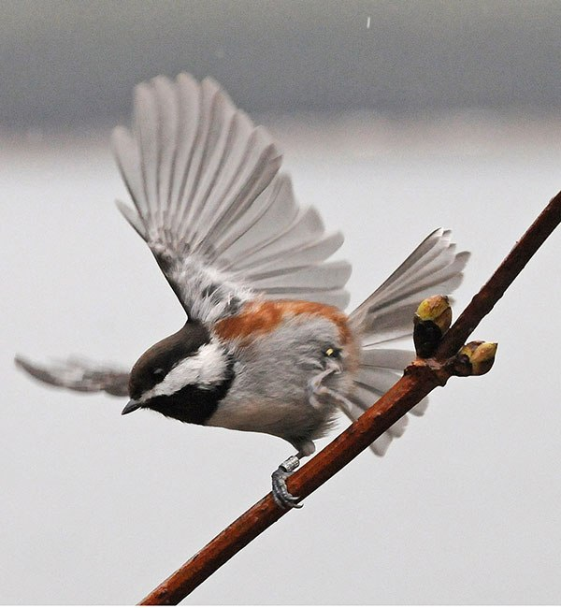Chestnut-backed chickadee. Photo by Bob Armstrong
All the chickadees share the habit of nesting in tree cavities. The cavities may be natural ones left by a broken branch or a woodpecker, or they may be excavated in soft, decaying wood by the chickadees themselves. Clutch sizes tend to be large, averaging seven or eight eggs per nest. Both parents care for the chicks, but in some cases, not all the chicks in a nest have the same father because, as in many other birds, some hanky-panky goes on! Predation on nest contents of cavity-nesting birds is commonly lower than for open-cup nesters, but nest predation on chestnut-backed chickadee nests can be as high as fifty or sixty percent of nests; red squirrels are a principal predator on eggs and chicks.
When chickadees forage through the canopy, they often hang upside down to glean from the undersides of twigs and leaves. They can do this very agilely, reportedly thanks to well-developed special leg muscles. Chestnut-backs often forage in flocks in winter, sometimes joined by other species such as nuthatches and kinglets. In the southern part of their geographic range, as many as fifteen other species have been recorded in mixed-species flocks with chestnut-backs.
Where chestnut-backs overlap with black-capped chickadees in Washington, their foraging patterns differ slightly. Chestnut-backs have slightly smaller bills and are more closely associated with conifers. They forage especially on foliage and twigs, while the blackcap forages more often on the bark of tree trunks and branches. Although both of them hang upside down to reach the undersides of leaves, the blackcap reportedly does so more often.
Chestnut-backs apparently have been much less intensively studied than blackcaps, which is arguably the best-studied songbird in North America. Because detailed information about chestnut-backs is hard to find, I thought I’d summarize some of the details about blackcaps, which range all across North America and nest in the Interior of Alaska. It seems likely that much of what is known about blackcaps also applies to chestnut-backs, but that remains to be ascertained. In the meantime, here is some cool stuff on blackcaps, particularly their winter flocking and its consequences, food storage behavior, how they get through the cold season, and their calls.
The winter flocks of black-capped chickadees are strongly hierarchical, with males generally dominant to females and older birds dominant to younger ones. Winter ranks have carry-over effects to the subsequent breeding season. Dominant male breeders are in better body condition than subordinates and tend to have better nesting success, at least in some habitats. They also participate more than subordinates in hanky-panky outside of the socially monogamous pair. Higher winter ranks of females also lead to their better survival in the breeding season.
Black-capped chickadees store food in fall and winter, each one stashing hundreds and sometimes thousands of seeds and insects in bark crevices or among conifer needles or in cracks in trunks and branches. Unlike red squirrels, which create piles of cones, the chickadees generally store items singly. They are very good at remembering where these items are stashed, being able to retrieve them after several days or even weeks, if one of the many potential thieves (squirrels, mice, nuthatches…) has not stolen them.
The part of the brain associated with memory is called the hippocampus, which increases in size in the fall, when food storage is a common activity. Blackcaps in the north store more food and have larger hippocampi than those in the southern part of their range. Blackcaps also have larger hippocampi than chickadee species that do less food storage.
Dealing with cold winter temperatures requires metabolic energy, and the colder the weather, the higher the metabolic costs. Blackcaps in Alaska are reported to have a metabolic rate about fifteen percent higher than those farther south. Heat generated by the muscular activity of foraging, during the day, also contributes to staying warm on winter days. At night, however, blackcaps allow their body temperatures to drop ten or twelve degrees centigrade, saving substantial energy; however, the blackcaps in Alaska are a bit different (of course?), and only let their temperature drop about three degrees. At night, they roost in cavities or in thick vegetation, usually singly.
The calls of black-capped chickadees may sound to us like indistinguishable twitterings. But not so, among themselves. They can distinguish the subtle variations in each other’s calls and identify specific individuals (as can many other songbirds). Furthermore, the “chick-a-dee” alarm call varies according to the relative risk from a potential predator that is visible; a different call indicates a predator that has been heard. Other species, such as nuthatches, eavesdrop on blackcap alarm calls and respond to the signal. Recent research has shown the male black-capped chickadees sing at higher pitches when the level of anthropogenic noise is high (for example, near heavy traffic, construction, logging activity, and so on), which may have consequences for breeding (as it does in some other songbird species too).

