Dragons and Damsels by Mary Willson
extraordinary lives of odonates
A few days ago, I stood beside a small pond, watching showy insects zoom around. There was a small blue damselfly, checking out the weeds in the shallows. And there were two of its larger dragonfly cousins: a couple of big darners and several smaller emeralds, so-named for the intensely green eyes and greenish body of mature adults.
There are over 30 species of dragonflies and damselflies in Alaska, and in Southeast we have around 19 species (3 damsels and 16 dragons). As they become better studied, more species will probably be added to the lists. The state dragonfly is the four-spotted skimmer.
Dragon- and damsel-watching is an increasingly popular recreation. Even without bothering about taxonomic details and the minutiae of species identification (which commonly requires having the creature in hand), the behavior of these conspicuous insects can be fun to observe.
My own introduction to this group, collectively called odonates (”toothy”), came several short eons ago, when I was a graduate student. I was studying yellow-headed blackbirds in the marshy potholes of eastern Washington, where these birds, along with red-winged blackbirds, were abundant. Perhaps the most important prey the blackbird parents fed to their chicks were recently emerged odonates.
Odonate larvae are aquatic predators, capturing prey with a huge, extensible, hooked lip. They may spend a year or two, or sometimes more, in the water, feeding and growing.
Damselfly larvae breathe by means of three external gills at the back end of the slender body; the gills also help in swimming. Dragonfly larvae have internal gills, and they breathe through the back end of the digestive tract.
When they are ready to become adults, the larvae crawl up on a plant stem or rock, the larval ‘skin’ or exoskeleton splits open, and the new adult pulls itself out. Blood is pumped into the long abdomen and into the wings, which gradually expand and slowly harden. These newly emerged adults are called tenerals. They fly very weakly until their body and wings harden. So this is the stage of their life when they are extremely vulnerable to predators, such as the blackbirds. The blackbirds I was observing stuffed their chicks with tenerals all day long.
As fully mature adults, odonates are much harder for birds to catch. Odonates have four wings, which can be moved independently of each other, giving them great maneuverability in the air. Adult odonates are terrific predators of other insects, catching the prey in a basket formed by their spiny legs, and munching them up in strong jaws. They have huge eyes of multiple facets, which are fine motion-detectors. Some odonates hunt by almost constant flying and searching, and others are sit-and-wait predators, perching on a lookout spot and darting out after a passing bug.
Each adult flies for only a few weeks. During that time it forages and plays the mating game. Males of some species are territorial, defending part of a pond from other males, and waiting for females to visit. Others cruise around, looking for potential mates.
The mating process in odonates is unique among insects. The male produces sperm, which he transfers to a special chamber at the front part of the abdomen. He does this by bending forward and placing the tip of his abdomen at the entrance of the storage chamber. When he finds a female, he grabs her with special appendages on his ‘tail’, holding her by the top or back of the head. The pair may fly around in tandem for a while.
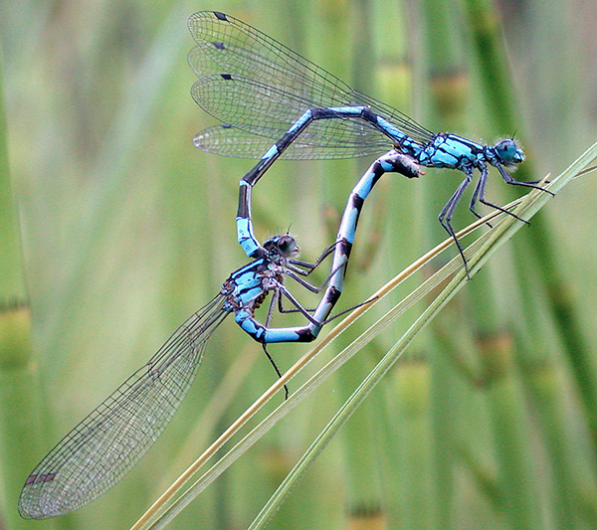Bluets mating. Photo by Bob Armstrong
The female then loops her abdomen forward to connect with the special sperm storage chamber. In this circular or ‘wheel’ position, a pair may fly around some more. The sperm are transferred to the female, where they fertilize her eggs.
But that’s not all: females can mate with more than one male. Competition for females is intense, and males have a nifty way of beating out competitors. Their penis does more than transfer sperm. It also can remove or push aside the sperm of males that mated with this female previously. So, if this male is the last one to mate with her, he ensures that he is the father of her eggs.
In some species, the male stays with the female, either in tandem or nearby, keeping guard on his paternity while she lays the eggs. In other species, females just sneak off on their own and try to avoid getting grabbed by other males. Given what goes on in many birds and mammals, I have to wonder if some females might not let themselves get caught by a new male, if he looks like a better specimen and potential father.
Females lay their eggs in several ways. Some typically insert their eggs into plant tissue, using a sharp structure called an ovipositor (egg-placer). Other species just drop their eggs into water or dap them onto mud or moss.
It is easy to observe territorial aggression, tandem and wheel flights, and sometimes oviposition in these insects. Such behaviors are often easier to watch in odonates than in many birds.
Here are three nice introductory guides to odonate watching:
Dragonflies of Alaska (second edition), Hudson and Armstrong;
Introducing the Dragonflies of British Columbia and the Yukon, Cannings;
Dragons in the Ponds, Armstrong, Hudson, and Hermans (for children).

