**[Flowery fun in Gustavus](https://onthetrailsjuneau.wordpress.com/2017/08/09/flowery-fun-in-gustavus/)**

an orchid show, and other floral delights by Mary Willson

Lady’s slipper orchids are sometimes called moccasin flowers, referring to the shoe-like shape of the flower. One of the petals is modified to form an oval pouch with an opening on top. The edges of the pouch are rolled inward. A small shield-like structure hangs down into the back of the pouch and behind the shield are the sex organs. The flower offers no nectar to visitors, but at least some species have an attractive aroma.

Bees that visit these flowers enter the pouch, but the rolled-in edges keep them from crawling out. So, once in the pouch, the bees are obliged to crawl up behind the shield, in order to get out again. In doing so, they pass very close to the pollen-receiving stigma, leaving pollen from previously visited flowers, and the pollen-bearing stamens, picking up pollen on their bodies to carry to another flower. A very elaborate system for creating the next generation of lady’s slippers.

After pollination, thousands of dust-like seeds are produced. They are so small that they contain no nutrition for a developing embryo (this is true of orchids in general). Lacking a source of nutrition, the seeds have to rely on forming an association with certain fungi (mycorrhizae), in order to germinate and grow. Lady’s slippers are slow growing and take several years to reach the flowering stage.

There are dozens of species of lady’s slippers in North American and Eurasia. They belong to the genus *Cypripedium*. This name is derived from some ancient Greek words. Cypris is an old name for Aphrodite (a.k.a. Venus in Latin), the goddess of love and beauty. The ‘ped’ part of the name refers to foot or footwear, sometimes rendered as ‘sandal’. So Cypris/Aphrodite/Venus has a rather large collection of sandals in her wardrobe!

Lady’s slippers were familiar to me, from years spent in the Midwest, but I have never seen them in Juneau. So one of my hopes for a recent Gustavus trip was seeing these in bloom. We’d seen their leaves occasionally in the past, but the plants were not then in flower. On this June trip, with the help of a knowledgeable naturalist there, we located clusters of three species of *Cypripedium*. There was a large-flowered white one (*C. montanum*, or mountain lady’s slipper). A small-flowered, round white one with some brownish spots is called *C. passerinum* (sparrrow’s egg or northern lady’s slipper). A yellow-flowered species has often been classified as a subspecies of *C. calceolus*, but more recently botanists seem to consider it to be a separate species, *C. parviflorum*, the small yellow lady’s slipper.

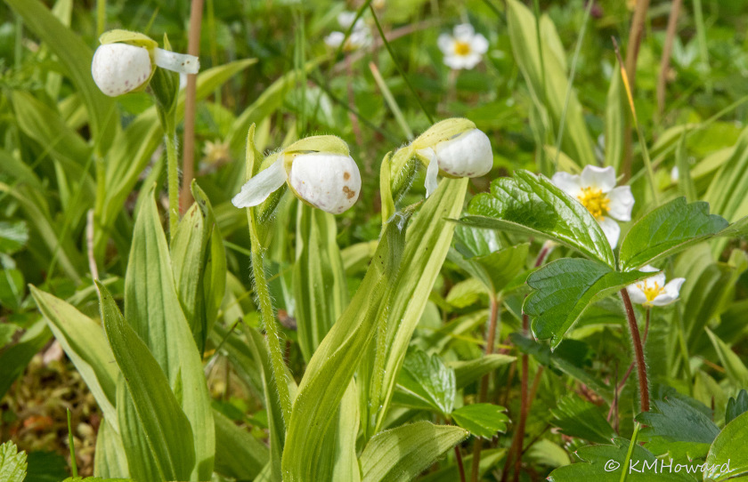*Cypripedium passerinum*, sparrow’s egg lady’s slipper. Photo by Kerry Howard

Lady’s slippers and many other showy orchids are often collected from the wild by willful gardeners. But this practice has led to the near-extinction of some species. The slow-growing habit, low levels of pollination and seed set, and the need for mycorrhizal fungi make recovery of exploited populations slow and difficult. So these plants should never be harvested from their native habitats.

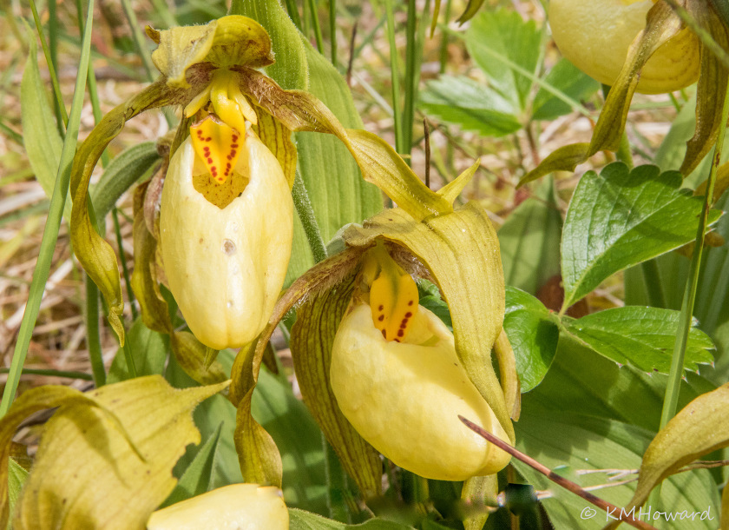*Cypripedium parviflorum*, small yellow lady’s slipper. Photo by Kerry Howard

We found other orchids too. Tiny twayblades are much more common in Gustavus than in Juneau. They are pollinated by minute flies and wasps, as Darwin documented long ago. Coralroots and so-called rattlesnake plantain are common in Juneau as well as Gustavus.

Orchids were not the only flower show in town, however. Lupines created hills of blue on the beach dunes. Cow parsnips and buttercups brightened beachside meadows. Roses and irises added splashes of color. One meadow was thoroughly decorated with the small white inflorescences of Tofieldia, which is easier to say than the ponderous common name of sticky false asphodel. Sticky it is—the stem sometimes captures tiny insects. Apparently, some botanists thought the inflorescence resembled the European asphodel, which in Greek mythology grew in the meadows where the souls of the dead walked. Great stretches of forest understory were carpeted by the leaves of deerheart, which sent up its small white spires of flowers, and the nearly-luminous, wide, white flowers of bunchberry (one of my companions is alleged to have said that they lighted the way to the outhouse in the darker hours!).

Indian paintbrush provided the most stunning floral array. Here in Juneau we see some yellow-flowered ones and (especially at higher elevations, I think) a few red-flowered ones. But in Bartlett Cove we found a beach meadow simply covered with paintbrush flowers: yellow, red, orange, particolored, and every combination in between. Quite splendid.