Green Alder Sawfly – A New Invasive
Posted on June 1, 2011 by grottaa
By Paul Oester and Dave Shaw, OSU Extension Service
History
A native of Europe, North Africa and the Near East, the green alder sawfly (Monsoma pulveratum) (Hymenoptera: Tenthredinidae) was first found in North America in eastern Canada in the early 1990’s, then in Alaska in 2004. More recently, the green alder sawfly was identified in trap samples in nine Washington counties and one Oregon county (Multnomah). Examination of insect collections at Western Washington University indicates that this insect has probably been present since 1995. It was first detected in the contiguous United States on understory shrubs in Vancouver, Washington in April 2010. We don’t know a lot about this insect but we are beginning to tease out how it operates.
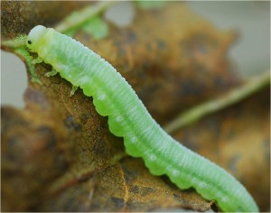Figure 1: Green alder sawfly larva (photo by Jim Kruse)
How do you identify this critter?
Adults emerge from overwintering sites in the soil or dead wood in the spring and lay eggs on expanding alder leaves. New larvae are very pale green and 2-3 millimeters long. Over time, as the larvae mature, they become a vibrant green (Figure 1). When fully grown larvae are about 15-18 millimeters long, a little more than ½ inch. The adults look like a small wasp, and the females (males have not been recorded in North America or the UK) have a black head and antennae. The middle (thorax) of the adult insect is black, sometimes with some yellow or brownish coloration; their legs reddish brown to black and abdomen black with the margins of the segments white to yellow (Figure 2).
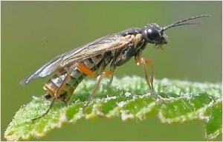Figure 2: green alder sawfly adult (photo by Andrei Karankou)
Life history
A pre-pupal stage overwinters and pupation occurs in the spring. After the eggs hatch in the spring, larvae feed on alder leaves through the spring and early summer, then typically drop to the ground to pupate in the soil. In Europe and recently observed in Alaska, these insects have been reported to also burrow into rotten wood to pupate (Figure 3). Just another reason not to move firewood interstate.
What about potential impacts?
Not much is known about how this insect will fare on red alder in western Oregon and Washington, as well as other species throughout these two states. In Alaska, this species has been feeding primarily on thinleaf alder (Alnus tenuifolia). There is some concern that the feeding of the green alder sawfly, woolly alder sawfly and the striped alder sawfly combined with stem cankers may lead to reduced nitrogen inputs by alders and perhaps alder mortality.
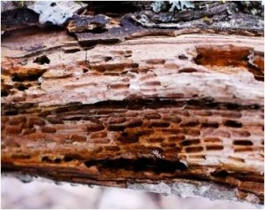Figure 3: green alder sawfly pupal niches (photo by Jim Kruse)
In the Pacific Northwest, several insects feed on alder species so these may compete for host foliage and the additional feeding by the introduced sawfly may have a minor effect. However, the green alder sawfly begins feeding earlier in the spring than other species and could effectively outcompete native species if foliage becomes limited. Another concern is the native parasite/predator complex: will these make the switch to the new invader?
What to do?
Efforts by federal and state agencies will include trying to delimit the extent of the sawfly’s distribution and encouraging more monitoring as well as research and education. The US Forest Service point person for this invasive insect is Kathy Sheehan, based in Portland. She is coordinating the effort to determine the distribution of the green alder sawfly in Oregon and Washington. They have already set up trapping sites throughout western Oregon in particular. Eradication is not a feasible option because of the widespread distribution of detections in Washington and Oregon. The fact this invader can potentially pupate in dead wood is another reason to manage the distribution of firewood and keep it local.
The bright green larvae are distinct. If you are out and about in your forest, look for these critters on alder leaves and if you find any likely suspects contact Amy Grotta at the Extension office, 503-397-3462, Dave Shaw, OSU Extension Forest Health Specialist (dave.shaw@oregonstate.edu) at 541-737-2845, or Kathy Sheehan (ksheehan@fs.fed.us) at 503-808-2674. For more information, go to http://www.fs.fed.us/r6/nr/fid/invasives/green-alder-sawfly.shtml.
References
Green Alder Sawfly. 2010. Forest Health Protection, Pacific Northwest Region, USDA Forest Service. 4 pages.
New Pest in Alaska and Washington: The Green Alder Sawfly-Monsoma pulveratum (Retizius). 2010. Pest Alert. USDA Forest Service State and Private Forestry Alaska Region. R10-PR-002. 2 pages.

Share this:

- Email

