High tides
long-tailed voles and short-eared owls by Mary Willson
In early October, the highest tides of the year (over 20 feet) brought sea water up close to the airport dike trail. Much of the extensive meadow of grasses and sedges was flooded. Although there had been 18-foot and 19-foot tides in previous months, this area is so flat that just another foot or two of water means that much more area is covered.
In intervals between big tides, long-tailed voles move out into the meadow, looking for food and perhaps even nest sites. Voles typically eat green vegetation and seeds. They have a very rapid reproductive cycle; the time from conception to sexual maturity is just a few weeks. But that short period is not sufficiently short to fit between monthly big tides of 18 or 19 feet. The mega-tides of 20 feet, however, occur at wider intervals, and voles could nest successfully in the meadows that are only covered by the biggest tides.
Whether nesting or exploring, the voles in the tidal meadows encounter major adventures with the coming of the mega-tides. As the water creeps up through the grasses and sedges, the voles flee. We can sometimes see them swimming for their lives toward higher ground, including the sides of the dike itself.
When that happens, predators have a good time. During the early October mega-tide, a friend watched an eagle snatch a vole from the water. Then a gull swept in and took another. (I was on the dike trail but apparently in the wrong place at the wrong time, since I missed the action).
In a different year, another friend saw a short-eared owl perched out in the meadow. The owl pounced on a swimming vole and sank partway down into the water. The owl pulled itself and its prey up and went to a nearby little snag, where it swallowed the vole whole. Twice! Down the gullet once, then coughed back up, and then down again, this time permanently. (What a trip!)
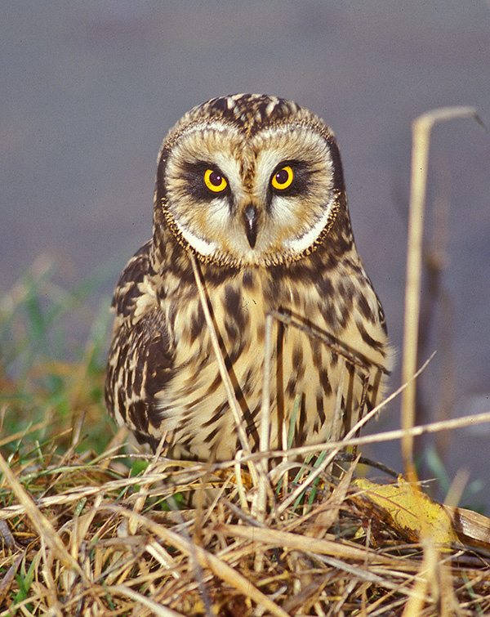Photo by Jack Helle
Short-eared owls are widespread, but they are quite specialized. They inhabit grassy areas and open fields, where they flit low over the ground in search of prey. They sometimes take large insects and small birds, but voles are a favorite food. Naturalists have collected regurgitated pellets of short-eared owls from the wetlands, inspected the undigested bones and teeth in those pellets, and found that long-tailed voles comprised most of the diet. Here in Southeast, they are migratory, passing to or from their nesting areas in the Interior.
Sadly, they sometimes view the grassy edges of the airport runway as foraging habitat, where they are at risk of being shot and killed. I wonder if that grass could be replaced by some other material that wouldn’t attract voles and owls (and geese), and thus reduce the worries about bird strikes by airplanes.

