How young birds learn by Mary Willson
out of the nest and into the stream
Someone saw a photo of a fledgling dipper in a local stream and asked me how young dippers learn to do all the things an adult must do—fly, swim, dive, forage, and (by next spring) sing the proper song and engage in courtship and chick care. The simple answer to this question is that I don’t know—and I don’t think anyone else has a precise answer either, because the development of behavior in this species has not been studied well.
But we can make some semi-educated guesses about some of it. Rather than dealing with the vast literature on learning by birds in general, perhaps it is useful to focus on this local charismatic species as a way of introducing the subject of learning in birds (even if there are still a lot of unknowns for this particular species). It seems likely that much of the education of juvenile dippers occurs by some observational learning (i.e., watching parents) mixed with a lot of trial and error. In other words, a lot like human toddlers.
Just before leaving the crowded nest, young dippers start to flap their puny wings, but there is not much room for wing action. When they jump out of the nest, they flap, and flap some more, building up strength as they flutter from rock to rock. Their flight feathers develop more, and with increased strength and better feathers, they flap more effectively. Parents may encourage them by holding a juicy prey item at a little distance, telling the chick to come and get it. From there on, it is probably a matter of trying variations in coordination and seeing what works, and then a good deal of practice.
Swimming skill may develop gradually. It may be innate (genetically programmed) to paddle the feet when the fledglings land on water, but then they need to practice and see what moves work best. They need to learn to use the currents and eddies to best advantage. Diving is another matter altogether. Do they see their parents do it and try to imitate? Or do they start diving spontaneously, even if parents are not demonstrating?? When do they begin diving? Who knows?
All the aquatic activity requires the ability to shed water from the feathers so the bird does not get waterlogged, and that, in turn, requires dressing the feathers with oil from the big gland at the base of the tail. So it probably takes several days before the chicks figure out how to preen their feathers properly, so that swimming and especially diving can be done without getting soaked. When the feathers get soaked, all that nice insulation that keep the bird warm in the cold water becomes useless. Furthermore, a soggy cloak of feathers doesn’t hold much air, so a wet bird is less buoyant when surface swimming. Preening is thus an important activity, but when it becomes fully functional is a mystery at present.
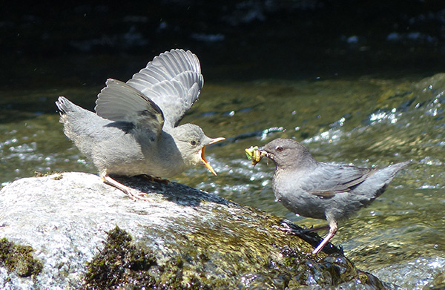Photo by Bob Armstrong
Young dippers have some experience with bugs and fish that are brought to them by their parents. They may recognize some of these prey items when they venture out of the nest and start peering into the water. But if they are like baby barnyard chickens, they probably poke and peck at some inappropriate and inedible items too, before they hone their prey-recognition skills.
After two or three months, juvenile dippers are fairly proficient at flying, swimming, diving, and foraging.
They need to be! The short days of winter and the (usually) cold weather mean that food-finding must be really effective, to get the energy needed to keep warm. And come spring, the new adult must be ready to hold a territory, find a mate, and care for chicks of its own.
How do dippers learn their proper song??I don’t think that song-learning has been studied in this species, and it is hard to make decent generalizations, because song-learning varies hugely among species. For instance, in some species, the song is entirely innate (e.g., brood parasites, whose chicks are reared by foster parents of other species), but this is less likely to be true of dippers, who (like most birds) raise their own young. In many songbirds, there is a critical, limited period for learning the proper song from their parents and neighbors; beyond a certain age, no further song-learning occurs. Still others go on learning new songs their whole lives, adding new notes and patterns to the repertoire and deleting others (e.g., mockingbirds). For dippers, it is likely that songs are learned, and polished with practice, but the specific details of song development are not known. However, even very young fledglings start to sing a soft sub-song, especially when their siblings are near, so the process begins early.

