Just received word about where the bird had been banded ... see below. Pretty amazing ... Gus

From: "Juan G. Navedo" <jgnavedo@uach.cl>
To: "Jim Johnson" <jim_a_johnson@fws.gov>, "GUS VANVLIET" <gusvanvliet@gci.net>, "brad andres" <brad_andres@fws.gov>
Sent: Monday, May 6, 2019 8:37:24 AM
Subject: Re: [EXTERNAL] Banded/RED-flagged [JTE] Hudsonian Godwit sighting at Eagle Beach, Juneau, today

Hi Jim,

Many thanks for sending this resighting.

JTE was banded by our Lab along with 34 conspecifics by February 13th 2018 at Caulín Bay, close to Ancud village, Chiloé island.

Thanks Gus for pursuing to find the ringer. Is it ok for you if I made a Twit from our Lab including this photo and your full credits as observer? Do you have a Twitter account?

Best and thanks again,

Juan G. Navedo, PhD
Bird Ecology Lab
www.birdecologylab.cl

Instituto de Ciencias Marinas y Limnológicas
Universidad Austral de Chile

&

Director
Quempillén Experimental Field Station
Ancud, Chiloé
Universidad Austral de Chile

jgnavedo@uach.cl
+56 63 2292550
Ext. 4550
skype: jgnavedo
Twitter: @birdecologylab

De: Jim Johnson <jim_a_johnson@fws.gov>
Enviado: lunes, 6 de mayo de 2019 12:17:45
Para: gusvanvliet@gci.net; Juan G. Navedo; Brad Andres
Asunto: Fwd: [EXTERNAL] Banded/RED-flagged [JTE] Hudsonian Godwit sighting at Eagle Beach, Juneau, today

Hi Juan,

One of your birds was seen by Gus van Vliet in Juneau, Alaska.
Would you please inform Gus when and where you captured it?

Regards,
Jim
Begin forwarded message:
From: <gusvanvliet@gci.net>
Date: May 5, 2019 at 9:24:21 PM AKDT
To: Jim Johnson <jim_a_johnson@fws.gov>
Cc: brad andres <brad_andres@fws.gov>
Subject: Re: [EXTERNAL] Banded/RED-flagged [JTE] Hudsonian Godwit sighting at Eagle Beach, Juneau, today
RED flag code JTE ... I've cropped the photo to reduce file-size and have re-attached ... does it work now? Thanks, Gus
On May 5, 2019, at 6:07 PM, <gusvanvliet@gci.net> <gusvanvliet@gci.net> wrote:

Hi Jim & Brad,

Today I found this bird (see attached photo) in a flock of 14 HUGO's at Eagle Beach, 27 miles north of Juneau. I have sent the info to the below site, but thought I would go straight to you both in case I could get a quicker reply as to where and when this bird was banded/flagged.

Best regards,

Gus

From: bandedbirds1@gmail.com
To: "GUS VANVLIET" <gusvanvliet@gci.net>
Sent: Sunday, May 5, 2019 5:52:20 PM
Subject: Thanks from BandedBirds.org

Thank you for your resighting data submission to [ http://bandedbirds.org/ | bandedbirds.org ] ! This email is confirmation that your submission has been received. Please check back to [ http://bandedbirds.org/ | bandedbirds.org ] and utilize our "Map Your Resight" feature to see where else the bird has been sighted.

<P1080618.JPG>
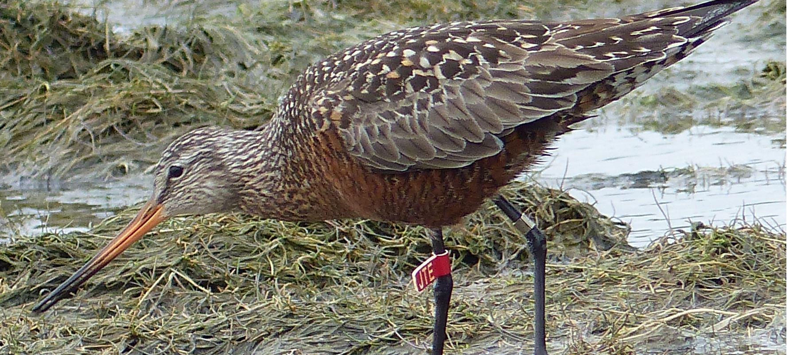

 | Virus-free. www.avg.com

