Otters by Mary Willson
they are surprisingly social
A week or two ago, I enjoyed watching a young otter, grooming and snacking, on the banks of my home pond. The next morning, when I peered out my windows, it was clear that the otter had come back, leaving a furrow in the snow, across the frozen pond, under my front-entry deck, and around the house. A few days later, it was back, scouting around the house and garden and checking out the pond, leaving a new furrow in the snow. Perhaps it has a regular (but temporary) route it follows, revisiting places where foraging has been successful in the past.
I’m guessing that this individual is a member of the family we often saw in the Dredge Lake area last fall. There were four big offspring with their mother. The young ones often stay with their mother into the winter and then disperse to live on their own. Dispersal distances are sometimes quite long, averaging almost forty miles for females in one Alaskan population (and slightly less for males).
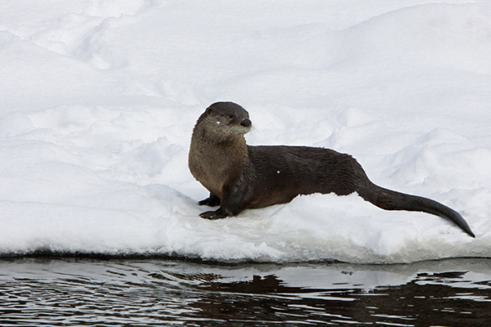Photo by Jos Bakker
Young otters continue to grow for several years, although they are said to be sexually mature when two years old. But males may not be “accomplished breeders” until they are five to seven years old, according to the literature. Mating usually occurs in spring in Alaska, but otters, like other members of the weasel family, have delayed implantation of the embryo. This means that the early embryo floats around in the female’s uterus for many months in a state of arrested development. Eventually, the embryo attaches to the uterus; active development begins and takes about two months.
The otters I’ve seen here in Southeast have been solitary or clearly a family group of mother and offspring. So I was very surprised to read that otters can be highly social. Males sometimes form long-term groups that forage together, perhaps breaking up in the breeding season when males go looking for mates, but then re-gathering for the rest of the year, and even staying together for several years. Nonbreeding females may join such groups. Occasionally a weaned offspring delays dispersal, staying home and helping the mother with the next litter.
As I skied around in the Dredge Lake area recently, I saw a long, brown shape poking around under the edge of the ice near a patch of open water. The otter emerged and foraged in the shallows until it noticed me, standing stock still on the trail. Then it bolted upstream. A bit later, I found a nice otter trail over the ice of one of the ponds, going out to a small area of running water and coming back toward the river. Hungry otters often cruise widely in their search for edibles. Almost any kind of meat is fair game for otters; although their mainstay is fish, they also eat mollusks, crabs, worms, frogs, and even occasional birds and small mammals.
Although their official common name is ‘river otter’, some folks call them ‘land otters’, perhaps to distinguish them from sea otters. Both common names are a bit misleading, because the versatile ‘river otters’ forage not only in rivers and streams but also on land and in the ocean. We often see them on rocky beaches when we are kayaking. I once watched an otter diving repeatedly down to a submerged bar between two islands; this was a banquet in salt water, apparently, because the otter brought up something edible on almost every dive.

