Pine siskins and common redpolls by Mary Willson
winter-hardy seed eaters
During November, people often asked me about the flocks of little brown birds that were seen swooping in unison from tree to tree. Sometimes a whole flock would whirl up and take off for some other location. These flocks were often quite large, numbering 300 or more birds, and just how hundreds of birds can fly so close together without bumping into each other is a wonderment.
These small, brown, flocking birds are pine siskins, relatives of goldfinches and redpolls. In our area, the most similar species, with the same flocking behavior, is the common redpoll. However, the redpolls do not usually arrive until February or so, remaining until then in the cold Interior where they breed in the summer.
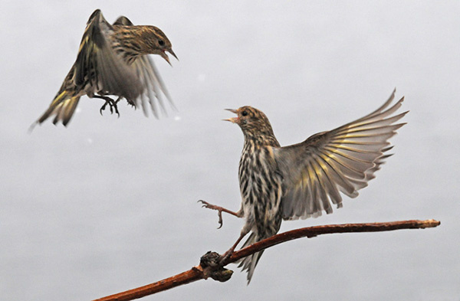Pine siskins. Photo by Bob Armstrong
Siskins and redpolls are the same size, roughly five inches long and weighing about half an ounce. Close up, you can see that siskins are heavily streaked with brown, with flashes of yellow in wings and tail. Redpolls are not quite so heavily streaked, and are distinguished by a red cap (as their name implies) and a reddish hue on the upper breast of the males (and no yellow flashes).
The yellow pigment in siskin feathers is produced by carotenoids, which birds cannot synthesize and so must obtain from their food. (Only a few birds, such as parrots, can make yellow pigments that are not based on carotenoids.) Carotenoids are found in leaves, fruits, insects (perhaps especially those that feed on leaves), and to some extent in seeds. In most yellow-feathered birds, the intensity of the yellow color depends on the amount of carotenoids the birds ingest; in some cases, chronic illness fades the colors.
Siskins vary in the intensity of the yellow flashes in wings and tail. There may be a tendency for males to have somewhat brighter yellow plumage than females, but this is said not to be a reliable indicator of gender, perhaps because the color depends on what the birds have been eating and how healthy they are.
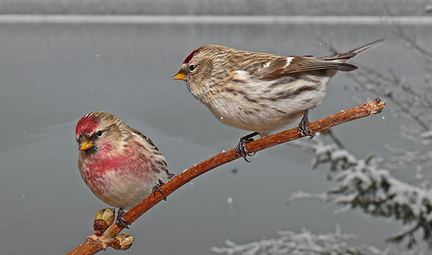Common redpolls. Photo by Bob Armstrong
The red of redpoll feathers is also carotenoid-based. In this case, the ingested carotenoids are modified by the bird’s metabolism to produce red instead of yellow pigment. Mature redpoll males and females can usually be distinguished, because males (but not females) have a red patch on the upper breast, but young males may lack the red patch.
When siskins and redpolls come to Southeast, the flocks often festoon the alder branches, where the birds dangle acrobatically as they extract seeds from the cones. When we have an early-winter influx of siskins, foraging heavily on alder seeds, I have to wonder how much they leave for the later-arriving redpolls. However, both species also feed on many other kinds of seeds, including spruce, birch, assorted weeds, and thistle in backyard feeders.
Both species are known as ‘irruptive species’, because their numbers in any one region can vary enormously. When seed crops are good in an area, huge numbers of the birds may arrive; 2010 was a year of bumper crops of spruce and hemlock around here, and perhaps alder too. Good seed crops allow siskins to breed as early as February. But when seed crops fail, the birds range widely in search of better foraging. They may travel hundreds of miles, suddenly appearing in huge numbers in the Lower 48; siskins even may travel to the Gulf Coast in some winters.
The strong dependence on seeds is associated with other habits, too. We often see these birds on the ground at the edge of the road in winter, where they are apparently attracted by salt, and possibly grit. Siskins are known to come to other sources of salt, such as a block of salt that has melted onto a stump in someone’s backyard, or ash in a firepit. There may be something about a diet of seeds that creates a need for salt and minerals.
Siskins put on more winter fat than redpolls, increasing their body weight by around 33%, which helps them survive the low temperatures and short days for gathering food. When redpolls molt in the fall, their new plumage is thicker than the old, worn feathers, providing better insulation; this is probably true, at least to some extent, for siskins also. Redpolls also gain muscle mass at low temperatures, perhaps in relation to shivering.
Redpolls are able to burrow into the snow, creating tunnels over two feet long that lead to a roosting chamber a few inches under the surface of the snow. Several birds may share a burrow, where the snow provides an insulating blanket.
Both species have the capacity to store seeds in a pouch that opens off the esophagus. A pouch full of seeds helps a hungry little bird get through a long winter night. The storage pouch has other uses too. In the nesting season, a male can carry a pouch of seeds to his incubating or brooding female; the seeds are regurgitated directly into the female’s mouth as the beaks of the two birds are held close together and crosswise (not tip to tip). And both adults can regurgitate a mash of seeds and bugs into their growing nestlings.
Both species often forage at backyard feeders, favoring thistle seeds and sunflower kernels. Siskins seem to be particularly feisty and aggressive, quarreling with each other and even with the larger juncos.

