Porcupines by Mary Willson
they sing and fight… and have dramatic sex lives
A young porcupine trundled up the trail ahead of us, one day in late September, before seeking cover in the forest nearby. The young ones are about half grown now and independent of their mothers. The mothers have other things on their minds, because fall is the mating season.
At this time of year, the males travel widely in search of willing females. The males ‘sing’, with a high, whining sound. Females coming into estrus send out scent signals and call with high-pitched screams or howls (as described by one researcher). One or two of these amorous creatures outside your bedroom window at night can be a little unsettling!
When a male finds a female before she is really receptive, he guards her from the approaches of other males, often perching in a tree below where she sits. Fights between males sometimes become fierce (and noisy), and the competitors end up with snouts full of quills. The battles may go on for several days. The winner then approaches the female and courts her; it may take a day or more to win her over. His first advances are often rejected with squawks and swats. He sprays her with urine from time to time; the urine presumably contains stimulating hormones. Gradually, they begin to talk softly to each other and they may rub noses. The final stage of courtship includes the male hosing her with forceful jets of urine that drench her with scent. To do this, he stands, grunting, on his hind legs and tail, with his male parts at the ready, and lets fly. This process often begins in the tree where the female was waiting, but then the pair goes down to the ground to copulate.
Copulation is tricky for prickly animals, but porcupines have it figured out. The female flattens out her quills, arches up, and brings her tail up over her back. The underside of her tail is less spiny than the top side. Copulation is brief and may be repeated until the male is worn out. One of the pair may then go back up the tree and scream, ending the encounter. The male, when he recovers, may go on to court other females. If fertilization is not successful, the female comes into estrus and may go through it all again.
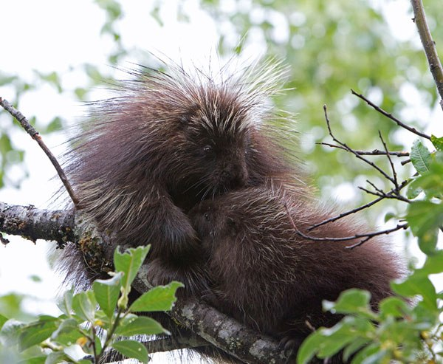Nursing baby. Photo by Jos Bakker
If fertilization is successful, she will be pregnant, with a single fetus, for about seven months—a very long gestation time for an animal that usually weighs less than about twenty pounds. The young ones are born in spring, emerging fully equipped with quills, which dry and harden in a few hours; the babies are quite capable of defending themselves by thrashing the tail. They can’t climb until they are several weeks old but stay near the tree where the mother is foraging or napping. They start eating green vegetation when they are about two weeks old but continue nursing until they are four or five months old. Nursing is accompanied by mutual humming and purring. Apparently, the female cleans urine and feces from her baby until it is able to climb and get itself away from ground-level predators; the cleaning reduces the scent cues for would-be predators.
As the fall mating season approaches, mother and young separate. Young females tend to disperse more widely than males, before settling on their own home ranges. Females are sexually mature when one year old, but males don’t mature until age two years.

