Purple mountain saxifrage
By Mary Willson
On the Trails in Juneau
A curious naturalist explores Southeast Alaska
a hardy flower and a spring delight
One of the earliest flowers to appear in spring is purple mountain saxifrage. In April some of us make a point of regularly checking certain places where we know it lives, just for the pleasure of watching for the first open flower and then the appearance of more and more blossoms, until there are multiple patches of the pinkish-purple flowers on some of the local rocky outcrops.
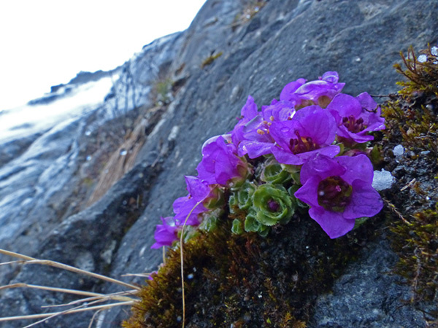Photo by Bob Armstrong
This low-growing plant occurs in Arctic regions around the world, and in alpine areas of central Asia, Europe, and North America. It’s a tough little plant, quite resistant to drought and water-stress. It forms associations with mycorrhizal fungi that provide nutrients and water, in exchange for carbohydrates produced by the saxifrage leaves. As with several other early-season bloomers, the flower buds are actually formed the year before the flower opens, but eggs (in the ovary) and sperm (in pollen) don’t develop until spring.
Female parts of the flower mature before the male parts do, which reduces the chance of self-pollination (pollen fertilizing future seeds in the same flower). Most seeds are produced by out-crossing (pollen fertilizing future seeds on a different plant).
The flowers are pollinated by insects of various sorts, including bees and flies. Early in May, we watched a female margined-white butterfly visiting one flower after another, so presumably there are minute amounts of nectar therein. These insects don’t see the longer (reddish) wavelengths, so they see the flowers as bluish. However, studies have shown that seed production is often limited by low levels of pollinator activity, perhaps in part because bad spring weather sometimes reduces insect activity. In addition, one study showed that as soon as other flowers started to bloom, insect visitation to the saxifrage decreased, as the insects found preferred sources of food.
This is an ecologically variable species, with different types adapted to different conditions of soil, snow-melt, length of growing season, and so on. For example, one study showed that the plants growing in cold, wet soils with late snow-melt had higher metabolic rates and faster production of shoots than those in warmer, drier sites, but they did less well at storing carbohydrates or water for hard times. In some areas, there are two growth forms that grow side by side but differ in structure (prostrate vs cushion-like) and in reproduction: one does better at seed production but the other excels at propagating by shoot fragmentation.
On the Old World Arctic tundra, purple mountain saxifrage flowers and old seed heads are eaten by barnacle geese when they arrive on the nesting grounds, and reindeer eat it too. I have not found information on animals that consume this plant in North America.
A word of caution: If you see this pretty plant in the wild, please do not remove it! That deprives lots of other folks of the pleasure of finding and seeing it in its natural setting.

