Spruce bud blight by Mary Willson
an unwelcome new threat to Southeast Alaska forests
There’s a new, probably non-native, invasive species in town, just discovered in late June. It’s a disease-causing fungus (Gemmamyces piceae) that afflicts spruce buds, often killing them altogether but sometimes just causing deformed buds and twigs. Heavily infected trees that lose many buds cannot make new needles that allow the tree to continue growing; old needles drop off naturally after a few years of service. Without new needles, eventually these severely damaged trees are likely to die. Although we know that Sitka spruce is susceptible, we do not yet know if it is prone to such severe, lethal infection. In any case, this is not something we would welcome in our multi-valued spruce forests!
Infestations of this pathogenic fungus were first noticed on the Kenai, in 2013, and later discovered near Anchorage and Fairbanks. Recent surveys have found that this fungus is apparently widespread in Southcentral and Interior Alaska, at least is road-accessible locations. Researchers are now beginning to study genetic variation in the population, which will help determine how long it has been in Alaska, as well as assess its native/nonnative status. Now it is in Juneau, on Sitka spruce trees near the Shrine of St Therese. Recognizing the potential seriousness of the now-localized outbreak, and in hopes of preventing its spread, scientists with Forest Health Protection at the Forestry Science Lab and the staff at the Shrine have worked together to remove and burn all spruce trees that show signs and symptoms of this fungal infection—to ‘nip it in the bud’, so to speak. This site and others will be now monitored by those scientists for indications that the infection has spread.
Researchers suspect that the fungus was introduced to Alaska by arriving on previously infected ornamental spruces that were brought in and planted. The movement of live plant material is a key pathway for the introduction of plant diseases. Colorado blue spruce, for example, is highly susceptible to this pathogenic fungus and is commonly planted as an ornamental in parks and gardens. In Europe, Colorado blue spruce has been widely used in plantations, to ‘replace’ logged-off natural forests, and in the Czech Republic the fungus has killed trees on many thousands of acres of those plantations of introduced spruces. Although the fungus was present in central Europe for some time previously, relatively recent environmental conditions of temperature and humidity probably made possible the destructive outbreak of the disease; the fungus does well in cool conditions.
Spores of this fungus disperse to new sites on the wind. But they also can be carried by rain, from infected upper branches to lower ones on the same tree. The existing fungal infections at the Shrine may already have sent spores to new sites, or it may do so in the coming weeks, if undetected infections remain. The spores infect next year’s buds, which are very small now (July); next year, these buds may be black and dead, or still alive but bent and deformed.
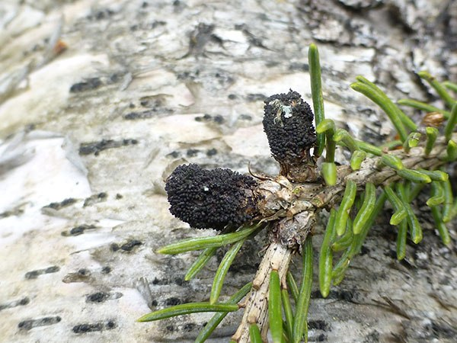Infected buds. Photo by Loretta Winston
What are the signs of infection by this fungus? When the fungus is mature, it develops a black, lumpy, spore-producing body on buds and new growth. One can see symptoms of previous infection on twigs that are two or three years old: they are bent at an angle, very unlike the natural growth pattern.
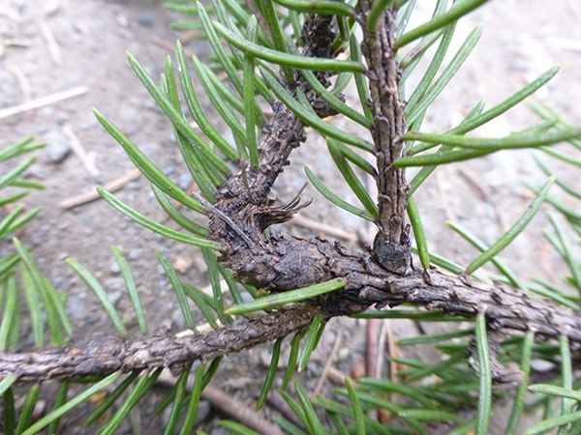Characteristic bent twig. Photo by Loretta Winston
Forest Health professionals at the Juneau Forestry Sciences Laboratory (U. S. Forest Service) are asking Juneau folks to be on the lookout for signs and symptoms of infection on our Sitka spruces. If you see them, please report them to Forest Pathologist Robin Mulvey (586-7971, 500-4962; rlmulvey@fs.fed.us). Send a close-up photo to her email if you can, along with precise location information. If you collect the infected twigs for a specimen, be sure to put them in a well-closed plastic bag so no spores can escape!

