**[Staghorn sculpins](https://onthetrailsjuneau.wordpress.com/2017/04/16/staghorn-sculpins/) by Mary Willson**

the interesting life of a perhaps-underappreciated fish

There are many species of sculpins in Alaska, mostly living in intertidal zones. One of the species a shore-bound person is most likely to see is the staghorn sculpin, so-called for the little ‘horns’ or spines on the rear edge of the preoperculum (a bone that helps cover the gills). Staghorns can be as long as 46cm and many live for several years. They are common in estuaries, but venture into fresh water as juveniles. As they grow older, they may move into deeper marine waters, down to about 50m, but many spend their lives in estuaries.

They don’t have any scales on their bodies, like some other sculpins, but which is unusual among fishes. They have very large pectoral fins that can be fanned out to the side. These are used for locomotion (forward or back), gliding down to deeper waters, or propping themselves up on a rock while they wait to spot a tasty prey item.

I got interested in staghorn sculpins after observing American Dippers capture them. Dippers often eat small fish, up to four or five inches in length. That’s a lot of fish for a bird that only weighs a couple of ounces. So dippers generally pound a captured sculpin on a handy rock, sometimes thrashing it as long as ten minutes. This subdues the squirming fish, makes the fins relax, and eventually may break the fish’s body into pieces, which are then consumed. A small sculpin, however, may be swallowed whole, headfirst, after being subdued. In winter, dippers often forage in estuaries, so sculpins are captured rather regularly.

These sculpins mature at age one year, and keep on growing. A large female can lay up to 11,000 eggs; some sculpin eggs are poisonous, but I have not been able to confirm that for staghorns. As in most (but not all) sculpins, in this species eggs are fertilized externally, as males and females just extrude their gametes into the water, during the winter months. The eggs are laid on rocks, where males tend them for about two weeks, depending on water temperatures. The larvae eat plankton and are found chiefly above the bottom. They turn into juveniles when they reach about 20mm in length and into adults at about 120mm in length. Juveniles and adults live on the bottom, where they eat amphipods, shrimps and crab, and worms; large juveniles and adults eat fish and large crabs.

One of their more interesting ways to feed themselves is by nipping off the siphons of clams. Reportedly, if a staghorn chances to bite the siphon of a butter clam that carries PSP, it may avoid them thereafter; although it will continue to eat siphons of clams that do not carry PSP. So PSP may help protect the clams from sculpins! If staghorns are prevented from chomping on the siphons of littleneck clams, these clams can then grow at twice the rate of clams with nibbled siphons. So there is a big cost to getting chomped by sculpins, and protection would be valuable.

Staghorn sculpin are eaten by many different marine mammals and birds, including large fishes (other sculpins among them), ducks, loons, herons, cormorants, pigeon guillemots, river otters, and sea lions. They are so vulnerable to predation that they have several means of trying to protect themselves. They may try to avoid being captured by partially burying themselves in bottom sediments. This doesn’t always work. And they erect those spines, with the sharp ends pointing up, if somebody threatens or grabs them. But some predators know how to avoid the spines. In addition, staghorns are cryptically colored in blotchy browns and grays, which makes them relatively inconspicuous. I would like to know if staghorn sculpin can change color, as some other species of sculpin do.

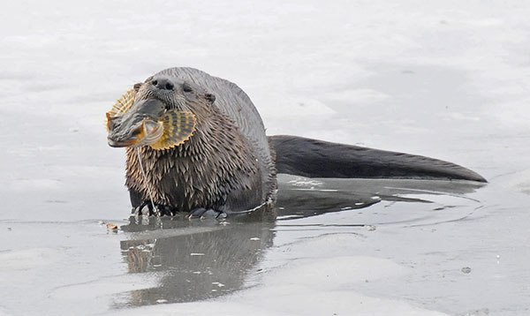River otters are fond of staghorn sculpins. Photo by Bob Armstrong

Researchers at UAS have studied cryptic coloration in another species of sculpin, the coastrange sculpin. This is a freshwater species that is also cryptically colored. Coastrange sculpins can change their colors to match the bottom of the stream, becoming darker or lighter, depending on the background. Some color changes take weeks, because new pigment cells in the skin have to be created or destroyed. But these sculpins can also change color quickly, in just a few minutes, by expanding or contracting the pigment cells. Some individuals are able to make greater changes than others. For example, small sculpins tend to be able to make greater color changes than larger ones.

The value of color shifts became apparent in simple experiments showing that light-colored sculpins on a dark background and dark sculpins on a light background were more often attacked by predators than sculpins that closely matched their background. Thus, the ability to change color is clearly adaptive. Interestingly, fish from a turbid stream with little overhanging vegetation exhibited more variation in color change than fish from a clear stream with lots of nearby vegetation. The researchers suggested that there would be a lower risk of predation in the turbid, unvegetated stream, because the sculpins would be less visible and there would be fewer predators. As a result, the ability to make rapid color changes when a sculpin changed its position and therefore its background, was less important there. Therefore individuals of differing ability to color-change could remain in the population. Where the risk of predation was thought to be greater, the researchers suggested that all individuals would gain protection by the ability to change color rapidly whenever they moved around, so there was less variation among individuals—the individuals that couldn’t change rapidly got eaten. Natural selection at work.

This work was done largely in Glacier Bay, which has been gradually deglaciated in the past two hundred years or so, and streams near the mouth of the bay are older than those near the still-receding glaciers. As a result, streams near the glaciers are turbid and surrounding areas have little vegetation, while streams near the mouth of the bay are clear and well vegetated. As the streams age, the risk of predation and the color of the stream bottom change, so the ability of sculpins to change color probably has helped them to colonize streams in the bay.