**Sticklebacks by Mary Willson**

…often overlooked, but very important fish

Advertisements

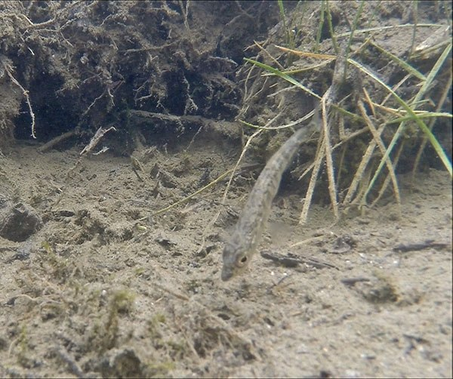This male stickleback is fanning his nest. Photo by Bob Armstrong

Last summer, I did a little fish trapping (with a permit) in some of the ponds in the Dredge Lake area. The most common fish in my traps were three-spined sticklebacks. These tiny fish-lets get no attention from most people, because they have no ‘value’ for sport or commercial fishing, but they are exceedingly interesting biologically and very important scientifically. The research literature on this species is vast, so this short essay provides only a sampling.

The three-spined stickleback is found in both marine and fresh waters; the marine form is anadromous, breeding in fresh water but returning to the sea. These fish are very small, seldom as much as three inches long, at least in fresh water. The males acquire bright colors in the breeding season, blue eyes and usually a red belly and sides. Intensity of the red color is an indication of health, and intensely red males are commonly preferred by females. In some populations, however, males have black breeding colors, or part black and part red; black males may not be preferred by females, but they are good fathers. Males build tubular nests of plant debris and invite females to lay their eggs there. The males then care for the several hundred eggs, fanning them to increase oxygen availability, guarding them, and so on, for about a week. It seems that males with the most intense breeding colors and males who court too long or too vigorously don’t have enough energy left to be good fathers—they invest more in getting eggs than in taking care of them once they have them.

They feed on all sorts of small aquatic organisms and, in doing so, can affect the composition and productivity of the entire lake ecosystem. In some lakes, there are benthic populations that exploit food that’s found near the bottom and limnetic populations that exploit food such as zooplankton that’s found in open water. These populations are genetically distinct from each other and differ morphologically in the position of the mouth and eyes, for instance.

Sticklebacks are an important source of food for many animals. Their many predators include fish (including their own species), birds, otters, and dragonfly larvae. To some degree, sticklebacks can protect themselves physically. The marine form has well-developed lateral plates and erectable back and pelvic spines. The spines help protect the fish, partly because the erected spines make the fish larger, in effect, so small-mouthed predators are less likely to attack, and partly because predators are more likely to release them after being stabbed by the spines. Otters are reported to eat the fish but leave a little heap of spines on the ground. Bird predators may be able to manipulate their prey so that the spines are made ineffective (But very young sticklebacks don’t have these spines; they develop as the fish grows—starting to appear when the young fish reaches about one centimeter in length.) The bony lateral plates provide another form of predator protection, rather like armor. These protective devices seem to work best against predatory fishes and apparently do not help much against dragonflies.

Marine sticklebacks have repeatedly invaded fresh water systems all up and down the coasts. When they do so, these protective devices are reduced or lost, in nearly every freshwater system these fish inhabit. Without the lateral plates, the fish make quicker starts to escape from an approaching predator, such as a loon or merganser. So there is a tradeoff between armored protection and ability to escape by fleeing. Pelvic spines are often much reduced in lakes that lack predatory fishes, particularly when the lake water is low in calcium (it takes calcium to build bones and spines). If predatory rainbow trout are introduced to these lakes, populations of these poorly protected sticklebacks decline.

Most predators are not capable of wiping out whole populations of sticklebacks, but just winnow out the slow or poorly protected ones or those that live in a particular habitat. However, one predator seems to be responsible for driving several stickleback populations to extinction. This rapacious predator is the northern pike, which was foolishly introduced to Alaskan lakes in the 1990s. In some lakes, no sticklebacks are left. A few other lakes, with deeper water, still have sticklebacks, mostly the limnetic forms, largely because the deep water gives them some space to escape from the pike.

These little ‘no-account’ fish are scientifically important for at least two reasons. One is the speed at which freshwater adaptations are acquired. The classical view of evolution is that it is very slow, requiring thousands of years. Yes, some evolutionary changes have taken a long time. But the sticklebacks provide one example (of an increasing number) of very rapid evolution, with morphological changes occurring in just a few years. For example, Middleton Island was uplifted by the 1964 earthquake, creating new beaches and ponds. Sticklebacks from the sea have colonized those freshwater ponds and lost their pelvic spines and lateral plates. Sticklebacks recolonized one Alaskan lake in the 1980s. In 1990, most of the fish still had lots of lateral plates. But by 2001 (less than twenty years after arriving and only eleven years after the first sampling), most of the fish had few lateral plates.

Interestingly, the genes involved in these changes are not always the same in every freshwater system, indicating that there are multiple ways of achieving the same adaptation. In fact, different populations of sticklebacks in different freshwater systems are often quite different genetically, and probably really represent different, very closely related, species. The dynamic evolutionary changes in these populations offer scientists wonderful opportunities to study both pattern and process of evolution and species formation.

Another reason these fish are scientifically important is that the entire genome has been sequenced, so we know the precise composition of their DNA. It turns out that about 70% of their genes are just like ours. This is likely to have medical implications: If we learn which genes control what features in the fish, there is then a possibility that some of those genes also control similar features in humans. For example, if certain genes control the loss of bony plates and spines in the fish, could those genes perhaps be involved in human bone deterioration (as in osteoporosis)?