**[Sunflower sea stars](https://onthetrailsjuneau.wordpress.com/2017/03/08/sunflower-sea-stars/) by Mary Willson**

big, fast, and flexible

One day in March, I walked a local ‘pocket’ beach. Among the accumulated crab claws, fish bones, rockweed bits, and mussel shells at the high tide line were two disarticulated arms of the sunflower star. (Sea stars are not fish, so the old name of starfish is obsolete.) I don’t know much about this (or any other) sea star, so I set out to learn a little.

Sunflower stars range from the Aleutians to Baja, usually in the subtidal or lower intertidal zones, but sometimes much deeper—down to several hundred feet. Unlike other sea stars, they are quite soft-bodied and flabby. All the tiny bones that link together to make other sea stars firm and nearly rigid are only loosely connected in sunflower stars. Instead, the sunflower stars depend on internal fluid pressure to maintain their body form and probably also get some support from the water they inhabit. This arrangement may prevent them from using upper intertidal zones that are frequently de-watered and may get them into trouble if they accidentally find themselves in the upper zones without access to water; among other dangers, they would be exposed to freezing temperatures that could be harmful.

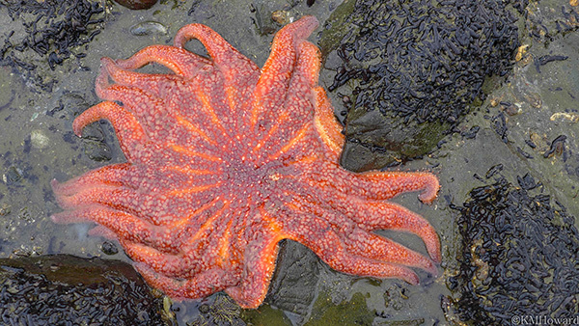Photo by Kerry Howard

These are arguably the largest sea stars in the world, sometimes well over three feet in diameter. Adults can have up to twenty-four arms, although the juveniles start with just five and add arms as they grow. All those arms bear thousands of tube feet that are used to cling to rocks or clam shells or even to dig pits in the sediments to nab a buried mollusk. These sea stars can move rapidly (for a sea star)–over three feet a minute, and they sometimes travel several kilometers.

Sunflower stars are voracious predators (and scavengers) that eat almost anything that moves, including sometimes each other, and even some prey that doesn’t move. They can evert their stomach and wrap it around a prey, digesting it externally. Or they can engulf a prey with their mouth and digest it internally. We once found a big sunflower star that was stranded in the upper intertidal zone with a sizable cockle still held in its mouth.

These sea stars could be called the Terror of the Subtidal Zone. They are capable of stripping a wide area of all the resident sea urchins, a popular prey. Many of their prey animals can detect the approach or the touch of this predator and take evasive action: moving higher in the intertidal or burying themselves deeper in the sediment. Sea cucumbers twist and squirm and try to swim away. Some snails clamp down on a rock or retract entirely into their shells; some exude a noxious slime that has a deterrent effect. Cockles turn somersaults and try to roll away. Despite numerous observations of the escape behavior of the prey, I have not found much information on the relative success of different tactics. One study compared the defenses of two species of sea urchin: One species tries to ward off a sunflower star with long spines, and that is more effective than the tiny pincers employed by another kind of urchin.

Sunflower stars typically spawn in spring and summer, occasionally in winter. They are broadcast spawners, shedding their eggs and sperm into the water. To do this, they are reported to stand up on the tips of their arms, raising the body above the substrate, so the gametes flow down into the water or onto the substrate. Stars can not only regenerate a lost arm or two, but if they are more seriously fragmented, the fragments reportedly can regenerate the missing parts and reconstitute whole stars.

Sunflower stars are aggressive beasts, seldom tolerating closeness of other sunflower stars or stars of other species, but they are occasionally found piled up together, for reasons that don’t seem to be clear. They appear to be susceptible to certain diseases or other afflictions: a major die-off was reported off the coast of Vancouver Island last year. Their predators are few but include large gulls, big crabs, and the morning sun star. These may harvest just an arm or two, leaving the sunflower star to regenerate new arms.