**[Winter white, summer brown](https://onthetrailsjuneau.wordpress.com/2017/03/22/winter-white-summer-brown/) by Mary Willson**

patterns of change in a seasonal world

This winter I’m seeing snowshoe hare tracks very commonly, in a variety of locations. Sometimes, repeated travels created well-packed hare highways through the brush. But I certainly don’t see the track makers very often, perhaps partly because I’m not out there at the times that they are most active. Another reason is that they are usually quite well camouflaged, with white fur in winter and brown fur in summer. Sometimes, however, the timing of the molt is not in synchrony with the background colors of the environment, and there’s a serious mismatch between hare and background: the hares become quite conspicuous as white patches on brown background or brown patches on white background.

There are at least ten mammal species in North America that show this kind of seasonal coat-color change, as well as some in Eurasia. In Alaska, we have the snowshoe hare, the Alaska hare, the short-tailed weasel or ermine, the least weasel, a species of collared lemming, and the Arctic fox. The ermine and snowshoe hare are the only ones in Southeast. Some of these species have large geographic ranges extending southward, where snow is less common, and the change to white doesn’t happen there; in contrast, hares in the Canadian High Arctic may not change to brown. In some cases, there is variation among individuals within a single population, some showing the seasonal change and others not. The general consensus seems to be that the observed coat-color changes are adaptive principally in providing seasonally appropriate camouflage and protection from visually hunting predators. Winter coats are often thicker and better insulated as well, but apparently the color itself does not greatly affect heat gain or loss.

As far as I can determine, in all species in which this has been studied, the physiological control of the coat-color change is driven mainly by photoperiod, or the relative lengths of day and night during a twenty-four-hour period, mediated of course by hormones. So if climate change brings less snow, but the physiological control of color change is still regulated by day length, there can be some serious mismatches between coat color and background. Seasonal timing may differ slightly for males and females, and for breeding animals vs nonbreeders. In some cases, temperature is thought to have a modifying effect: warm temperatures in fall, for example, may delay the molt somewhat, or hasten it in spring, but this effect is generally less than that of photoperiod.

In the bird world, ptarmigan engage in seasonal shifts from brown plumage in summer to white plumage in winter, and back again. Here too, the principal driver of change is photoperiod, and there can be timing differences between male and female. For example, willow ptarmigan females get their brown summer plumage earlier than males.

The most intriguing species is the rock ptarmigan. Males sport a showy white plumage in spring, for weeks after the snow has melted and their females have molted to a cryptic brown (which makes them very inconspicuous while incubating eggs in the nest). Males keep their conspicuous white coat until well after their female consorts have laid eggs and are no longer fertile. However, when egg-laying is underway, the males do something very unusual: they start to make their white plumage dirty, and by the time egg-laying is complete, they are very dirty—and much less conspicuous– indeed. But if the clutch of eggs is destroyed by a predator, or if the female is killed, suddenly the bereft males clean their plumage to a brilliant white again, and go a-courting once more. Most rock ptarmigan mate monogamously, but a few males are polygynous (with more than one female) and some may not obtain mates in any given year. The bachelors and polygynous males stay clean white longer than monogamous males, in keeping with their protracted potential for mating. Eventually, all the males turn brown, until it is time to turn white for the next winter.

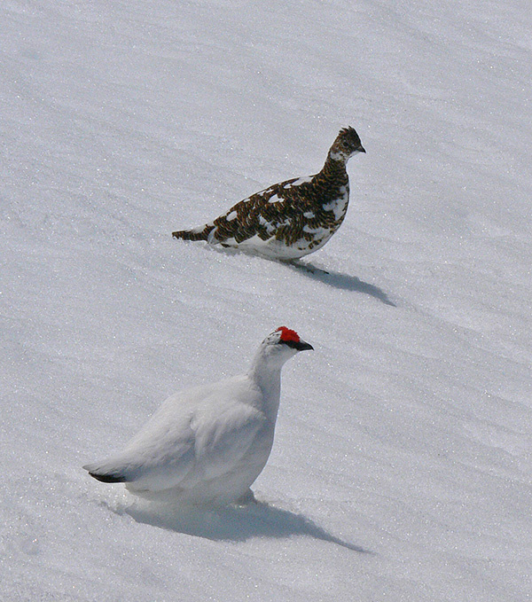Male and female rock ptarmigan in spring. Photo by Bob Armstrong

The rock ptarmigan use the seasonal pattern of plumage change for camouflage, like all the other animals that do the white/brown shift. But in addition, the males apparently use their white winter plumage as a sexual advertisement in spring and early summer, and female rock ptarmigan choose their males in part on the basis of this studly self-advertisement. There is no doubt a cost to showing off this way; rock ptarmigan suffer heavy predation, and those studly, conspicuous males are taking risks and paying a price.